**Visualizing hematopoiesis as a stochastic process**

Short title: A tool for simulating hematopoiesis

Jason Xu1, Yiwen Wang2, Peter Guttorp3, Janis L Abkowitz4

1Department of Biomathematics, University of California, Los Angeles, CA

2Department of Statistics, University of California, Irvine, CA

3Norwegian Computing Center, Oslo, Norway

4Department of Medicine, Division of Hematology, University of Washington, Seattle, WA

Please address correspondence to: Janis L Abkowitz, Box 357710, University of Washington, Seattle, WA 98195. Phone: 206-543-3360; Fax:206-543-3560. Email: janabk@u.washington.edu

Abstract: 111 words

Text: 2837 words

Figures: 5

Tables: 0

References: 29

**Key Points:**

1. Hematopoiesis is a complex, dynamic system and thus can be modeled stochastically.

2. The visualization tool can help investigators test concepts and hypotheses regarding normal, defective, and neoplastic hematopoiesis.

**Abstract**

Stochastic simulation has played an important role in understanding hematopoiesis, but implementing and interpreting mathematical models requires a strong statistical background, often preventing their use by many clinical and translational researchers. Here we introduce a user-friendly graphical interface with capabilities for visualizing hematopoiesis as a stochastic process, applicable to a variety of mammal systems and experimental designs. We describe the visualization tool and underlying mathematical model, then use this to simulate serial transplantations in mice, human cord blood cell expansion, and clonal hematopoiesis of indeterminate potential (CHIP). The outcomes of these virtual experiments challenge previous assumptions and provide examples of the flexible range of hypotheses easily assessable via the visualization tool.

**Introduction**

Hematopoiesis is an intricate system of checks and balances assuring that hematopoietic stem cells (HSCs) give rise to sufficient red blood cells, white blood cells and platelets to maintain homeostasis as well as respond to physiological stress. HSCs are infrequent (estimated as 1 per 104-105 marrow cells in mice and 1 per 108 marrow cells in humans 1-4, reside in specified niches which protect HSCs by assuring their relative quiescence and genomic integrity, and give rise to multipotent progenitors (short-term repopulating cells) whose subsequent divisions and differentiation maintain blood cell production.

Conceptually, HSCs are independent decision-makers; a cell’s decisions to differentiate, replicate (self-renew), mobilize, or die are determined by its unique combination of specific genetic, epigenetic and environmental inputs. Some of these cues are well-defined and well-studied, while others are unknown. An individual HSC’s behavior is not only unique but also dynamic, as its inputs can change over time. Thus, the fates of individual HSCs cannot be suitably predicted deterministically. Further, it is not possible to directly observe such fates, so one must rely on indirect methods, rendering the study of HSCs difficult.

That HSC decision-making is complex and incompletely prescribed, yet outcomes (i.e., differentiation, division, mobilization or death) are clear and distinct, make hematopoiesis an ideal system to be studied using stochastic modeling. Stochastic analyses have played a large role in modeling and understanding hematopoiesis, and have previously been applied to experimental observations in mice, cats, nonhuman primates and humans. For example, we have used this analytic approach to quantify mean rates of HSC differentiation, replication and death; estimate the total number of HSCs and compute HSC frequencies among marrow cells 3-7; and show that the number of niches regulates the number of HSCs 8.

However, mathematical subtleties and details of the assumptions and limitations of such models can be opaque to understand, especially for hematologists who lack computational or statistical backgrounds. This motivated us to develop a tool that enables non-statisticians to explore and understand how HSC decisions critically impact hematopoiesis. In this report, we introduce software that provides user-friendly capabilities for stochastic simulation and visualization of the hematopoietic process, allowing users to easily conduct virtual experiments and obtain estimates and uncertainty quantification from their outcomes.

This report presents the basic stochastic model underlying the hematopoiesis simulator, proposed by Guttorp et al 9,10 and successfully applied to studies in mice, cats, baboons, and humans 3-5,7,11-13 and demonstrates its utility in several examples. We then describe the visualization tool, which makes available a flexible range of virtual experiments by allowing users to vary parameters and observe the effects of changes. Next, we analyze serial transplantation experiments in mice and studies where “expanded” HSCs are transplanted along with unmanipulated marrow cells in humans, providing new insights to these observations. The tool is termed “HematopoiesisSimulator” and is available without charge for non-commercial use at <http://depts.washington.edu/ventures/UW_Technology/Express_Licenses/hemsim.php>

**Materials and methods**

**A stochastic model of hematopoiesis**

Mathematical models describe a natural phenomenon or practical problem quantitatively, and have been applied to hematopoiesis research since the 1960s 14. Stochastic models allow for random variations around some mean behavior as specified by the model parameters. By integrating randomness, relatively simply stochastic models can give rise to a broad range of observed outcomes. Stochastic modeling is therefore often more appropriate for describing very complex systems than deterministic models whose inputs must fully determine all observed outcomes. Deterministic models are more rigid, and when one simplifies such a model, it often fails to adequately describe a complex system realistically. In systems featuring a rich ensemble of observed outcomes such as hematopoiesis, deterministic modeling is intractable due to the large number of inputs required to generate the full spectrum of observations. Additionally, stochastic models are more versatile than deterministic models in that they provide quantification of uncertainty or variability (reviewed in 15,16).

As illustrated in Figure 1, HSC behavior in our model is described by three parameters: λ, the mean replication (self-renewal) rate; α, the mean apoptosis rate; and ν, the mean rate of differentiation to a multipotent progenitor (short-term repopulating) cell. An average rate for a specified outcome does not imply or require any particular biological mechanism (e.g., symmetric division, asymmetric division, a feedback loop, or an age/replication history dependent decision). We assume that fate decisions are Markovian, that is, that cells do not remember their past decisions, but rather act in a way dependent only on existing cues 17. The maximum number of HSCs (Compartment 1 cells), i.e., the maximum capacity of the HSC compartment, is denoted K.

Once a HSC commits to differentiation (leaves Compartment 1 and enters Compartment 2), the resulting clone contributes to hematopoiesis for a finite period of time. The mean time interval during which contributing clones support blood cell production is denoted 1/μ, and we assume that all contributing clones contribute equally.

Models such as this are termed stochastic hidden two-compartmental models, since we only can observe probabilistic behaviors of the second compartment (contributing clones). For example, the observations may consist of sampling committed progenitor cells in marrow or sampling granulocytes in blood, and not the direct observation of HSCs. In previous work, we demonstrated the capability of the stochastic model to analyze hematopoiesis in cats 6,11,12, mice 3,5,18, primates 7 and humans 4. The estimated parameters are consistent with other in vivo or model-based parameter determinations 4,5. Our studies suggest that K is very similar across animals of different size and lifespans 5. Results also suggest that μ is invariant between species, although its value is difficult to infer with precision 13,19.

Simulating hematopoiesis requires only the specification of the easy-to-conceptualize parameters K, λ, α, ν and μ, the number of HSCs of the start of the simulation, and the number of contributing clones at the start of the simulation.

**The visualization tool**

The Java-based simulator enables visualization of the stochastic model over time (see Figure 2). The program allows researchers to vary the four rate parameters λ, α, ν, and μ independently for two types of HSCs (termed, a and b). Thus, competitive transplantations where the two cell types have different behaviors can be simulated. In addition, researchers designate the initial number of HSCs (R0, i.e., the number (N) of reserve (compartment 1) cells at time 0), the initial number of contributing clones (C0, i.e., the number of contributing (compartment 2) cells at time 0), and the initial percentage of type a cells in each compartment. Total time period of simulation and sampling schedules can be altered as well. In addition, the simulator offers the option to have the HSC reserve increase without bounds or to cap the capacity of the HSC reserve and adjust replication fates so that N remains ≤ K, where K can be assigned. Thus, the user can designate how the model behaves when the total number of HSCs becomes greater than or equal to the capacity K. When a replication event is set to occur, the event can be neglected, which is the mathematical equivalent of one daughter cell dying as no niche is available. Alternatively, when a replication event is set to occur, the event can happen with a reduced probability so that K acts as a soft limit to the population. Moreover, the simulator provides the functionality to repeat many replicate simulations, display the control values (parameters, initial values, etc.), save the current set of control values, and load a previously saved set.

The simulator produces graphical outputs and summary statistics for both the HSC reserve (Compartment 1) and the contributing clones (Compartment 2). The time series of the percentage of type a cells in each compartment is also plotted. One can view the cellular composition graph and statistics of the two compartments in the process of simulation and revisit a certain time by using a slider (labelled “Plotting Delay”). The simulator also offers control over the time interval between each sample. The simulation results can be exported into a file under a given name or simply saved as a screenshot. Complete details about the software are provided in an accompanying manual.

The portability of Java code removes the platform restriction on the simulator. The simulator is composed of two core parts: the simulation engine and the presentation layer. The simulation engine is responsible for carrying out the stochastic simulation. It is built into its own jar file and can be invoked by other programming languages such as R (www.R-project.org), a language and environment for statistical computing and graphics, via the rJava interface 20. The presentation layer accepts user input, sends a request to the simulation engine and renders the output graphically.

**Results**

**Serial transplantation measures HSC quantity, not just quality.**

As an initial application of the visualization tool, we simulated serial transplantation experiments in mice. In typical serial transplantation experiments, investigators transplant murine marrow cells into an irradiated mouse, allow hematopoiesis to reconstitute, then 3-4 months later, transplant the same number of marrow cells from the first recipient mouse into a second irradiated recipient mouse; and 3-4 months later, into a third irradiated recipient, etc. HSC proliferative capacity or robustness is then defined as the number of transplantations that are feasible before host animals fail to reconstitute their hematopoiesis with the serially transplanted cells. It is assumed that HSC exhaust (are no longer capable of additional divisions) and that this exhaustion explains why cells do not persist after the 3rd or 4th serial transplantation. This assay is a standard method to quantitate HSC robustness 21-23.

A virtual experiment using the simulator tool and parameter values optimized for murine hematopoiesis (λ = once per 2.5 weeks, α = once per 20 weeks, ν = once per 3.4 weeks and μ = 6.9 weeks)3 reveals that this conclusion is premature. Intrinsic in the reasoning above is the requirement that the HSC compartment has fully reconstituted by 3-4 months after transplantation. However, simulation (see below and Figure 3) shows that this assumption is incorrect, and as a consequence, that the “exhaustion” observed in HSCs during serial transplantation can reflect HSC dilution, as was argued by some investigators in the early 1980s 24,25.

Figure 3 shows cumulative outcomes of 1000 independent trials of a serial transplant experiment, where 10x106 nucleated marrow cells are transplanted into irradiated mice. As a mouse is estimated to have 2.8x108 marrow cells 26, 10x106 cells are approximately 4% of the total marrow cell number. After 12 weeks (3 months), 10x106 marrow cells from the first recipients are “transplanted” into a second irradiated recipient, and so forth. Thus, hematopoietic reconstitution in each successive recipient begins with approximately 4% of the number of HSCs present in the previous donor at the end of the 12 week period. We observe that most virtual mice fail to reconstitute after 3 serial transplantations; and as seen in studies of real mice, none survive after the 4th transplantation. This simulation study thus demonstrates that this outcome may be explained solely by the fact that fewer and fewer HSCs are present among the 10x106 marrow mononuclear cells transplanted at later time points—the findings do not require that HSCs age or lose proliferative potential after repeated transplantation. Should one allow a longer time interval, i.e. 24 weeks (6 months) between transplantations, 4 serial transplantations are then feasible, as shown in the rightmost plot in the bottom panel of Figure 3. Similar outcomes are seen if 20X106 (8%), not 10X106 (4%), of marrow cells are transplanted to each recipient. This too is consistent with experimental observations. As also shown in Figure 3, if one transplants 20X106 marrow cells each 24 weeks, two thirds of the recipients survive after the 4th transplantation.

There are several implications in these findings. First, they show that serial transplantation studies assay HSC number. Components of HSC robustness such as a high HSC replication rate and the slowness of HSC to differentiate are also measured, but not the differentiation potential of HSC (data not shown). Second, after the transplantation of 10x106 marrow cells, one needs wait 27 months (i.e. longer than the average lifetime of a mouse) before its HSC compartment is fully reconstituted, even though the circulating blood cell count normalizes after 3-4 weeks. One would thus anticipate that a transplanted mouse throughout its subsequent life would be especially sensitive to chemotherapy or radiation that injures HSCs. The same issue pertains to larger animals and man as can be demonstrated using the visualization tool. A 70 kg man transplanted with 2x108 nucleated marrow cells/kg (i.e., approximately 150 HSCs in a 70 kg man) would not fully reconstitute the stem cell reserve (11,000-22,000 HSCs) for roughly 22 years, and would not have large numbers of HSCs (e.g., over 1000 HSCs) for about 12 years (simulations not shown).

**Expanded human progenitor cells can persist for 1 year.**

A second example where simulating human hematopoiesis can help interpret clinical observations concerns hematopoietic reconstitution after cord blood transplantation when two units are transplanted. In adults, one strategy is to “expand” one cord blood unit with cytokines, such as notch ligand, to assure a more rapid initial reconstitution of hematopoiesis. A second unmanipulated cord blood unit is simultaneously transplanted to assure that blood cell production is maintained. The clinical observation is that after one year, some cells derived from the first unit can persist 27. To determine whether this implies that HSCs were present in the expanded cell population that was infused—i.e. that the culture conditions not only expanded progenitors but also maintained some HSCs, we used the visualization tool to simulate from the stochastic model beginning with no HSCs, but only with cells in Compartment 2. As shown in Figure 4a, persistence of short term repopulating cells is indeed a feasible explanation for the clinical observations. This observation reveals that finding residual contribution from the expanded cord blood unit at one year does not imply that the unit contained HSCs. By effectively expanding progenitors, one could allow the concomitant graft of HSC (the second unit) sufficient time to replicate, reconstitute the stem cell reserve, and support hematopoiesis in the long run. This too can be shown via simulation by adding HSCs from the second unmanipulated cord blood unit into the simulations as population b. Multipotent progenitors from the expanded unit assure hematopoietic reconstitution during the first months after transplantation, while HSC from the unexpanded unit support long-term hematopoiesis in these simulations, as in practice.

**Discussion**

Visualizing the outcomes of stochastic simulations shows what can happen under a broad range of hypothetical experiments. It allows one to evaluate the plausibility of possible explanations and quantify their likelihoods and thus provides a powerful, informative method for analyzing and interpreting observational data.

Because one can simulate experiments under different experimental conditions, the visualization tool (Figure 2) also can help researchers design experiments to assure an interpretable outcome before initiating the study, saving both cost and time. For example, one might test various methods for competitive transplantation studies in mice by examining the simulated outcomes when two types of HSCs with different behaviors, type a and type b, are transplanted. Results of the simulation then could help select an optimal experimental design. By simulating serial competitive transplantation using the approach in Figure 3, one could determine what conditions might distinguish a defect in stem cell number from a defect in stem cell quality. One might also simulate studies in cats or non-human primates, compare the levels of variability between results, and estimate sample sizes, i.e. determine many studies would be needed for an answer up to a desired precision.

One can also simulate human hematopoiesis (i.e., Figure 4), and for example, test hypotheses about clonal progression in the myeloproliferative disorders or the emergence of a PNH clone after aplastic anemia. What if a single HSC were able to replicate on average 2x faster than other HSCs, would its progeny dominate blood cell production? And if so, how fast? What if the replication rate of aberrant HSCs was on average only 1.2X faster than other HSCs? If the multipotent progenitors derived from this HSC survived 2x longer than the multipotent progenitors derived from normal HSCs, would the clone then dominate? What if HSC differentiation were inhibited (e.g., the chance that a HSC differentiated was halved) but a single HSC that was able to differentiate normally remained, would its progeny dominate hematopoiesis and if so, with what time course and with what likelihood? What if both HSC numbers were decreased and differentiation impaired but a single HSC that was able to differentiate normally remained? Such questions can be tested as one could generate virtual patient outcomes and then assess whether they resemble observed patient data. Figure 5 displays how the simulator tool can be used to easily gain intuition about the first two questions, and in effect, serve to conceptualize possible initiations and evolutions of clonal hematopoiesis of indeterminate potential (CHIP)28,29.

The visualization tool makes simulation accessible and lets the investigator or clinician envision hematopoiesis as a dynamic and competitive process. Conceptualizing and visualizing hematopoiesis using this tool allows one to test hypotheses, assess their plausibility, and quantify outcomes.

**Figures**

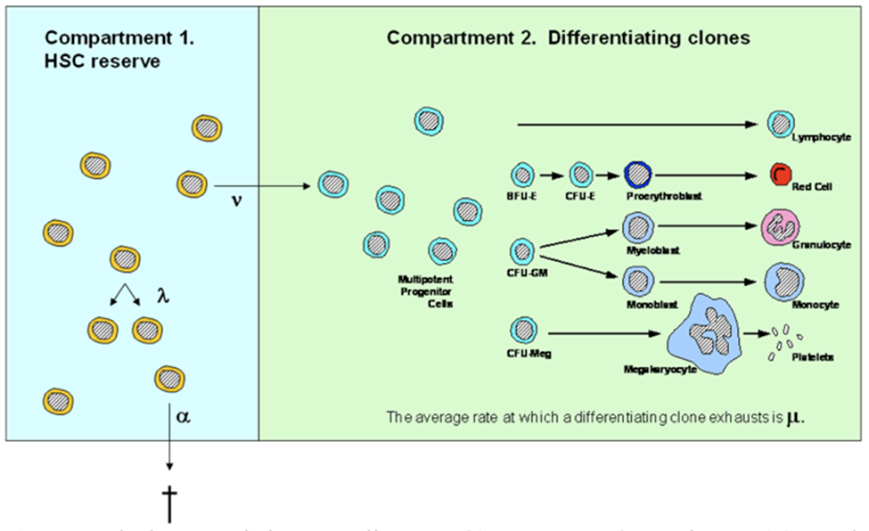

**Figure 1.** Illustration of the two-compartment hidden stochastic model for hematopoiesis. Adapted from 4.

The model designates three HSC behaviors: λ, the mean replication (self-renewal) rate (diagrammed as one HSC becoming two HSCs) ; α, the mean apoptosis rate (diagrammed as an HSC exiting from compartment 1); and ν, the mean rate at which a HSC becomes a multipotent progenitor (short-term repopulating) cell and heads a differentiating clone. Once a HSC becomes a multipotent progenitor (diagrammed as an HSC entering compartment 2), it and its progeny (termed a differentiating clone) contribute to the blood cell production which is observed for a mean of 1/ weeks. With this tool, one can determine if designated HSC behaviors could lead to experimental or clinical outcomes that are observed. See text for further details.

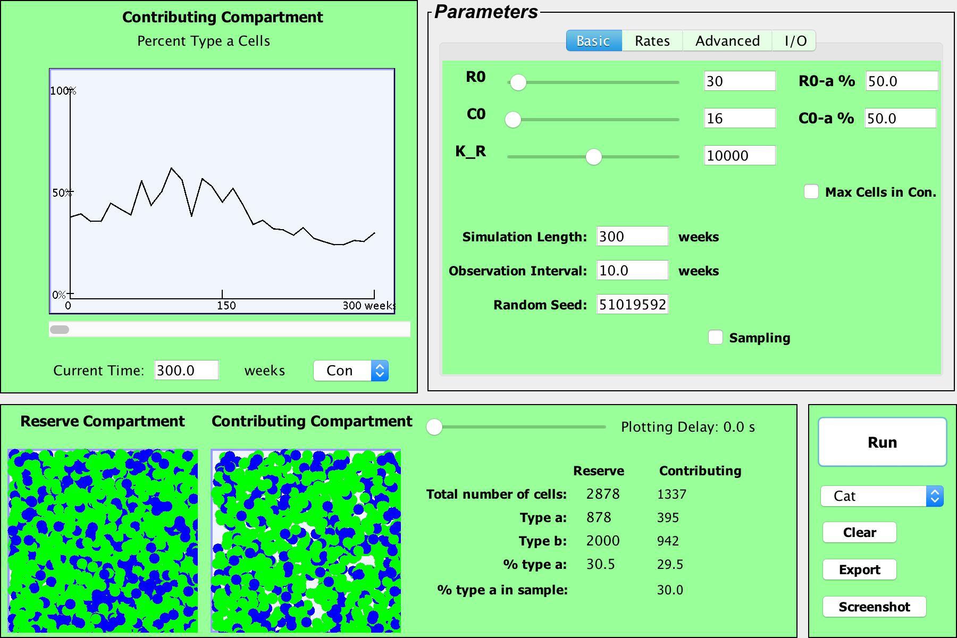 (A)

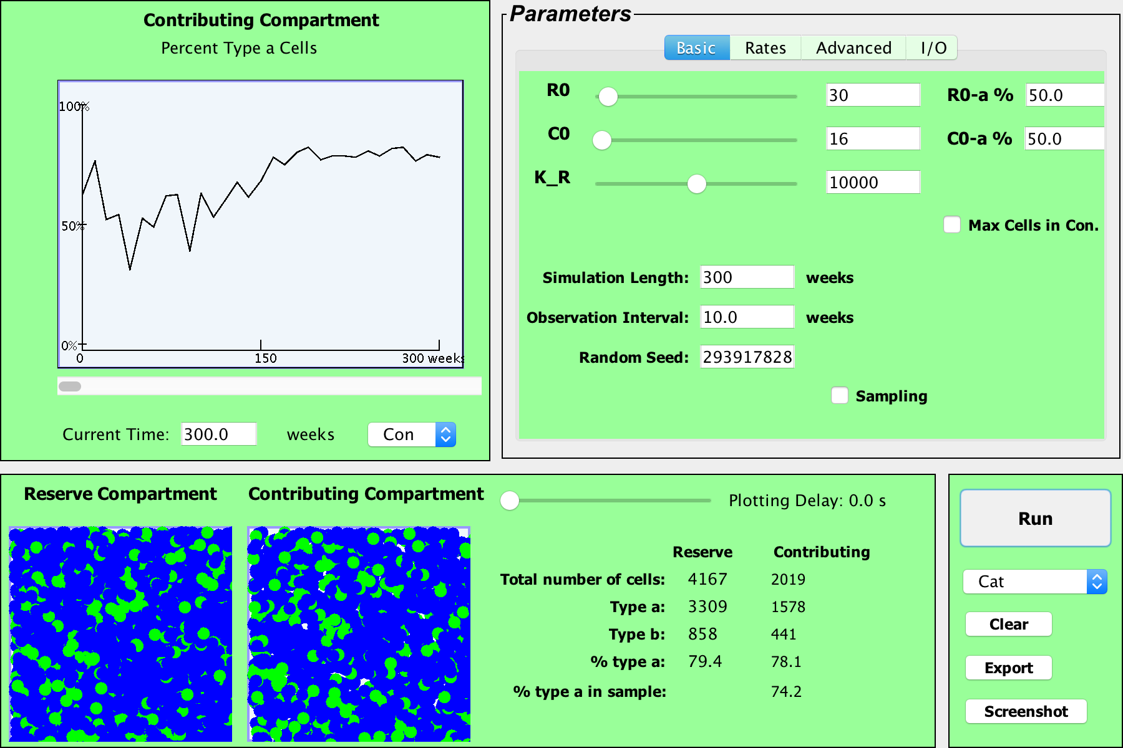 (B)

**Figure 2.** Screen shots of the current version of the visualization tool.

Shown are two simulations where a small number of HSC, 30 (R0=30) and the equivalent number of contributing clones that would be present in an aspirate of feline marrow containing 30 HSC (C0=16) are transplanted into a lethally irradiated cat. 50% of the initial transplanted cells are type a (blue) and 50% are type b (green), simulating the autologous transplantation of small numbers G6PD heterozygous marrow cells as in reference 12. Observations were plotted every 10 weeks for a 300-week (~ 6 year) interval. By the end of the simulation period in Figure 2A, 2878 HSC are present in the HSC compartment (or HSC reserve); 30.5% are type a. There are also 1337 contributing clones of which 29.5% are type a. Note that the HSC compartment is not yet full at 220 weeks (4 years after this transplantation) as the number of HSC (N=2878) is much less than the capacity of the stem cell compartment (K = 10,000 in this simulation). Model parameters, including λ, α, ν, and μ, of type a and type b cells, can be independently controlled under the “Advanced” tab (upper right). Data is preloaded for cat (shown), mouse, nonhuman primate and man, in accordance with references (3-5, 7, 9, 12-14). For cat, the preset value for λ = once per 10 weeks and ν = once per 12.5 weeks (9). The second simulation (B) has identical input parameters as the first simulation (A) but produces a vastly different outcome.

Macintosh HD:Users:jasonxu:Desktop:hema_JanPeter:commandLineHema:out:artifacts:HemaCLI_jar:4_12.pdf

*Macintosh HD:Users:jasonxu:Desktop:hema_JanPeter:commandLineHema:out:artifacts:HemaCLI_jar:fig4.pdf*

**Figure 3.** Virtual serial transplantation experiment in mice.

The top panels show the numbers of HSCs 12 weeks after an initial transplantation and after three retransplantations. Optimized values for λ (once per 2.5 weeks), α (once per 20weeks), ν (once per 3.4 weeks) and μ (6.9 weeks) were used 3, and are preset in the simulation tool. In these simulations of serial transplantations, mice receive 4% of the number of HSCs present 12 week after the previous transplantation. Histograms correspond to 1000 independent simulations of this process: as shown, by the third transplantation (recipient 3), approximately 70% of the 1000 virtual mice fail to reconstitute. By the final sequential transplantation, almost all virtual mice have a depleted HSC reserve (i.e., zero compartment 1 cells). The bottom panel displays similar histograms of the numbers of HSCs in the final recipients, and show the effects of varying the percent of marrow cells transplanted and varying length of time between the sequential transplantation. As expected, transplanting higher percentages of marrow cells or waiting longer between transplantations ameliorates the quantity of HSC dilution; the rightmost histogram shows that only about a third of the simulated mice will die from a lack of HSC when doubling the parameters of the experiment in the top panels.**Macintosh HD:Users:jasonxu:Desktop:hema_JanPeter:commandLineHema:humanblood1.pdf**

**Figure 4**. Simulation of expanded cord blood cell transplantation in humans.

The average numbers (Avg Pop) of short term repopulating cells (STRCs) remaining after one year is shown. Also shown is the dependency of this number on the length of time a STRC-derived clone contributes to blood cell production and the initial number of STRCs transplanted. Results derive from 500 independent simulations for each set of parameters. When the mean length of time a STRC-derived clone contributes to blood cell production is set at 12 weeks, rare clones often persist for one year or longer because of the stochasticity in expansion and differentiation decisions of progeny cells. Indeed, the plot indicates persistence whenever the mean STRC-derived clone lifespan is over 10 weeks and over 200-500 STRCs are transplanted. Thus, the argument that observing a cell at 1 year implies that it derived from transplanted HSC is not secure.

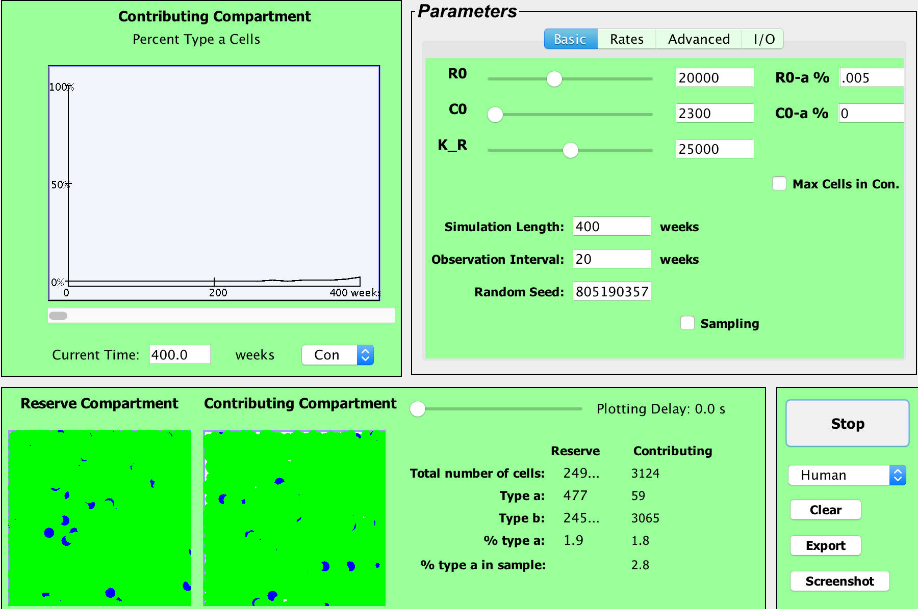(A)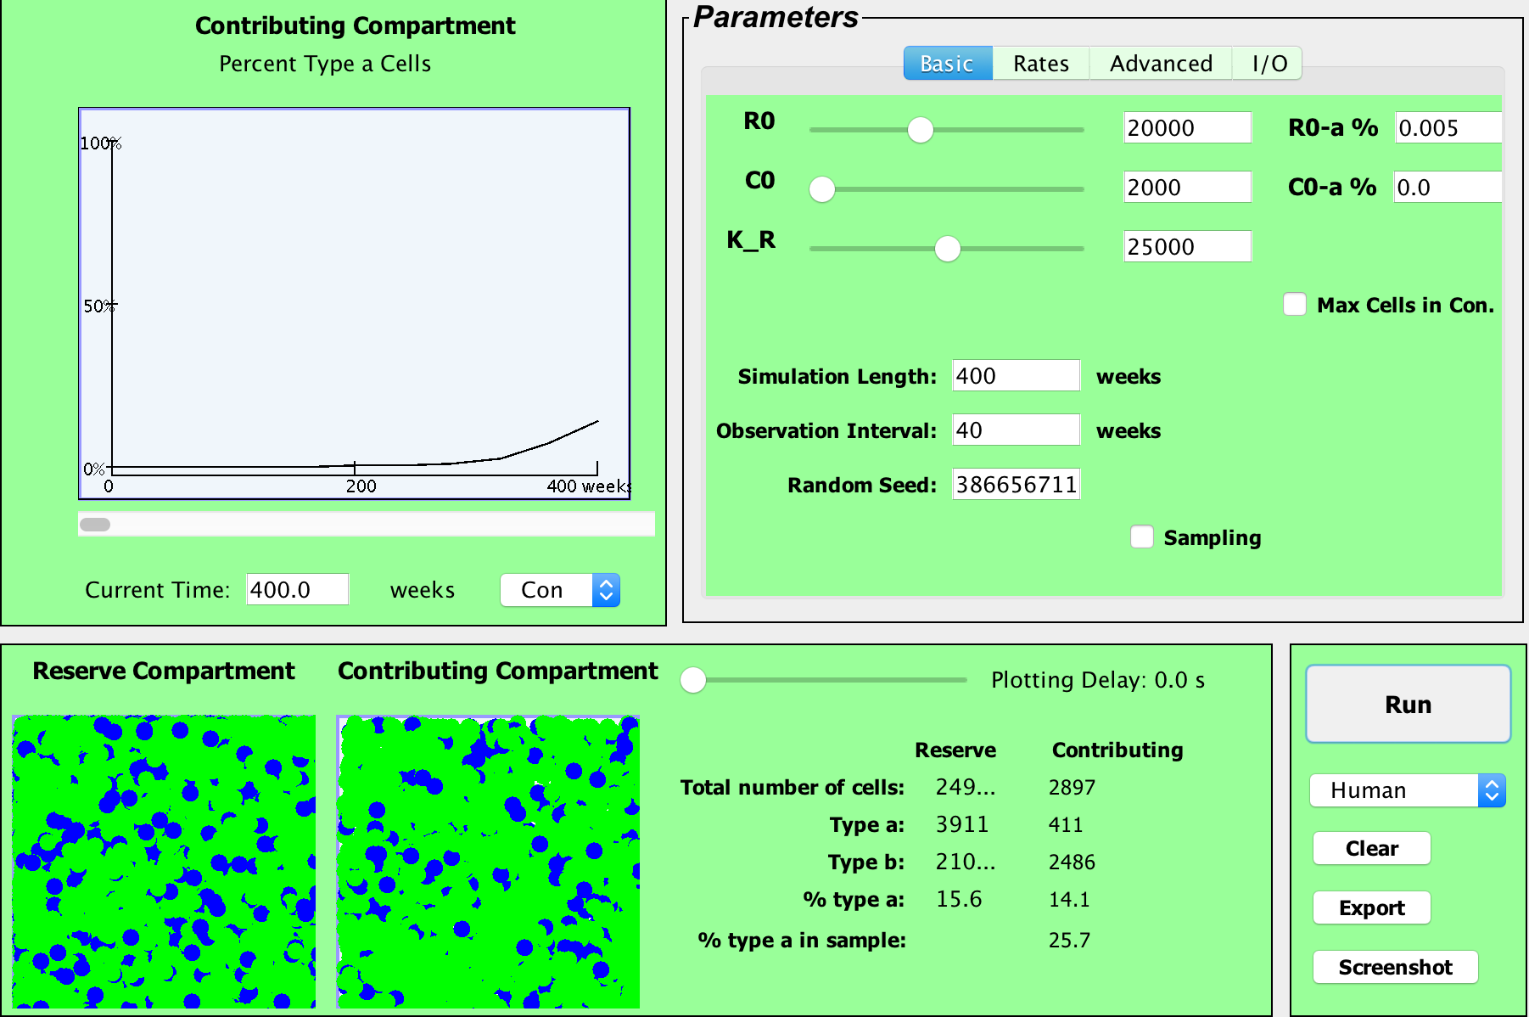(B)

**Figure 5**. Simulation of mutations yielding a replication advantage.

Example realizations of simulated human hematopoiesis under HSC mutation. Optimized values for λ (once per 40 weeks), α (once per 285 weeks), ν (once per 56 weeks) and μ (10 weeks) were used for the normal HSCs 4, and are preset in the simulation tool. Each simulation begins with one mutant HSC that self-renews on average twice as frequently (on average once every 20 weeks) as the 20,000 normal HSCs (which renew on average once every 40 weeks). In this thought experiment, the maximum numbers of normal HSCs plus mutant HSCs is set at 25,000. Mutant cells are represented as type a cells and appear as blue circles above. In roughly a quarter of simulations, mutant HSC replicates but never contributes to hematopoiesis (enters Compartment 2), or its clones transiently appear in Compartment 2 at very low levels. Panel A shows an example of this. Other times, the mutant clone very slowly expands in the stem cell reserve and then contributing compartments (Panel B). Conceptually, these simulations provide a virtual representation of CHIP (clonal hematopoiesis of indeterminate significance) 28,29.

In panel A, the clonal contribution reaches roughly 1% of Compartment 2 (STRCs), decreases to near zero, and then reaches 1.8% after 400 weeks. Panel B displays an example where the mutant clone persists, reaching a population of 411 mutant STRCs (of 2486 Compartment 2 cells or 14.1%) after 400 weeks. In this simulation, the number of mutant HSC (Compartment 1 cells) increases to 3911, or 15.6% of total HSCs. Expansions to 10 or more percent of HSC occurs in roughly a quarter of the simulations. In contrast, this rarely ever occurs when decreasing the replicative advantage of the mutant cell to once every 30 weeks. Varying the parameter values enables simulating hematopoiesis with different behaviors for a single mutant HSC, allowing one to visualize the differing physiologies under which clonal hematopoiesis could emerge or progress.

**Acknowledgements**

This work was in part supported by NIH R01 HL46598. We are grateful to Kenny Harrington, Angie Zhu, Youyi Fang, Andrew Hau, Arman Bilge and Zijin Wang for programming help.

Author contributions

JX designed and performed the simulation studies, analyzed data, and wrote the manuscript. ZW helped with programming and the user interface. PG and JLA conceived and designed the visualization tool, planned experiments, reviewed and analyzed data, and wrote the manuscript.

**References:**

1. Szlivassy SJ, Humphries RK, Lansdorp PM, Eaves AC, Eaves CJ. Quantitative assay for totipotent reconstituting hematopoietic stem cells by a competitive repopulation strategy. *Proc Natl Acad Sci USA*. 1990;87:8736-8740.

2. Uchida N, Tsukamoto A, He D, Friera AM, Scollay R, Weissman IL. High doses of purified stem cells cause early hematopoietic recovery in syngeneic and allogeneic hosts. *J Clin Invest*. 1998;101:961-966.

3. Abkowitz JL, Golinelli D, Harrison DE, Guttorp P. In vivo kinetics of murine hemopoietic stem cells. *Blood*. 2000;96(10):3399-3405.

4. Catlin SN, Busque L, Gale RE, Guttorp P, Abkowitz JL. The replication rate of human hematopoietic stem cells in vivo. *Blood*. 2011;117(17):4460-4466.

5. Abkowitz JL, Catlin SN, McCallie MT, Guttorp P. Evidence that the number of hematopoietic stem cells per animal is conserved in mammals. *Blood*. 2002;100(7):2665-2667.

6. Abkowitz JL, Taboada M, Shelton GH, Catlin SN, Guttorp P, Kiklevich JV. An X chromosome gene regulates hematopoietic stem cell kinetics. *Proc Natl Acad Sci U S A*. 1998;95(7):3862-3866.

7. Shepherd BE, Kiem HP, Lansdorp PM, et al. Hematopoietic stem-cell behavior in nonhuman primates. *Blood*. 2007;110(6):1806-1813.

8. Chen J, Larochelle A, Fricker S, Bridger G, Dunbar CE, Abkowitz JL. Mobilization as a preparative regimen for hematopoietic stem cell transplantation. *Blood*. 2006;107(9):3764-3771.

9. Guttorp P, Newton MA, Abkowitz JL. A stochastic model for haematopoiesis in cats. *IMA J Math Appl Med Biol*. 1990;7(2):125-143.

10. Newton MA, Guttorp P, Assuncao R, Catlin S, Abkowitz JL. Stochastic modeling of early hamatopoiesis. *J Amer Stat Assoc*. 1995;90:1146-1155.

11. Abkowitz JL, Linenberger ML, Newton MA, Shelton GH, Ott RL, Guttorp P. Evidence for the maintenance of hematopoiesis in a large animal by the sequential activation of stem-cell clones. *Proc Natl Acad Sci U S A*. 1990;87(22):9062-9066.

12. Abkowitz JL, Catlin SN, Guttorp P. Evidence that hematopoiesis may be a stochastic process in vivo. *Nat Med*. 1996;2(2):190-197.

13. Fong Y, Guttorp P, Abkowitz J. Beyesian inference and model choice in a hidden stochastic two-compartment model of hematopoietic stem cell fate decisions. *Ann Appl Statistics*. 2009;3(4):1695-1709.

14. Becker AJ, Mc CE, Till JE. Cytological demonstration of the clonal nature of spleen colonies derived from transplanted mouse marrow cells. *Nature*. 1963;197:452-454.

15. Ogawa M. Differentiation and proliferation of hematopoietic stem cells. *Blood*. 1993;81(11):2844-2853.

16. Kimmel M. Stochasticity and determinism in models of hematopoiesis. *Adv Exp Med Biol*. 2014;844:119-152.

17. Guttorp P. Stochastic modeling of scientific data. London: Chapman and Hall; 1995.

18. Catlin SN, Guttorp P, Abkowitz JL. The kinetics of clonal dominance in myeloproliferative disorders. *Blood*. 2005;106(8):2688-2692.

19. Golinelli D, Guttorp P, Abkowitz JA. Bayesian inference in a hidden stochastic two-compartment model for feline hematopoiesis. *Math Med Biol*. 2006;23(3):153-172.

20. Urbanek S. rJava: Low-level R to Java interface. R package version0.6-4. 2009.

21. Harrison DE, Astle CM. Loss of stem cell repopulating ability upon transplantation. Effects of donor age, cell number, and transplantation procedure. *J Exp Med*. 1982;156(6):1767-1779.

22. Hock H, Hamblen MJ, Rooke HM, et al. Gfi-1 restricts proliferation and preserves functional integrity of haematopoietic stem cells. *Nature*. 2004;431(7011):1002-1007.

23. Kamminga LM, Bystrykh LV, de Boer A, et al. The Polycomb group gene Ezh2 prevents hematopoietic stem cell exhaustion. *Blood*. 2006;107(5):2170-2179.

24. Ross EA, Anderson N, Micklem HS. Serial depletion and regeneration of the murine hematopoietic system: Implications for hematopoietic organization and the study of cellular aging. *J Exp Med*. 1982;155:432-444.

25. Iscove NN, Nawa K. Hematopoietic stem cells expand during serial transplantation in vivo without apparent exhaustion. *Curr Biol*. 1997;7:805-808.

26. Boggs DR. The total marrow mass of the mouse a simplified method of measurement. *Am J Hematol*. 1984;16:277-286.

27. Delaney C, Heimfeld S, Brashem-Stein C, Voorhies H, Manger RL, Bernstein ID. Notch-mediated expansion of human cord blood progenitor cells capable of rapid myeloid reconstitution. *Nat Med*. 2010;16(2):232-236.

28. Steensma DP, Bejar R, Jaiswal S, et al. Clonal hematopoiesis of indeterminate potential and its distinction from myelodysplastic syndromes. *Blood*. 2015;126(1):9-16.

29. Malcovati L, Galli A, Travaglino E, et al. Clinical significance of somatic mutation in unexplained blood cytopenia. *Blood*. 2017;129(25):3371-3378.